Meta Description:
Are you in search of the top social media marketing agency in Dubai? Read this guide to find the right one and all benefits associated with this choice.

Top Social Media Marketing Agency in Dubai | Grow Your Brand Online
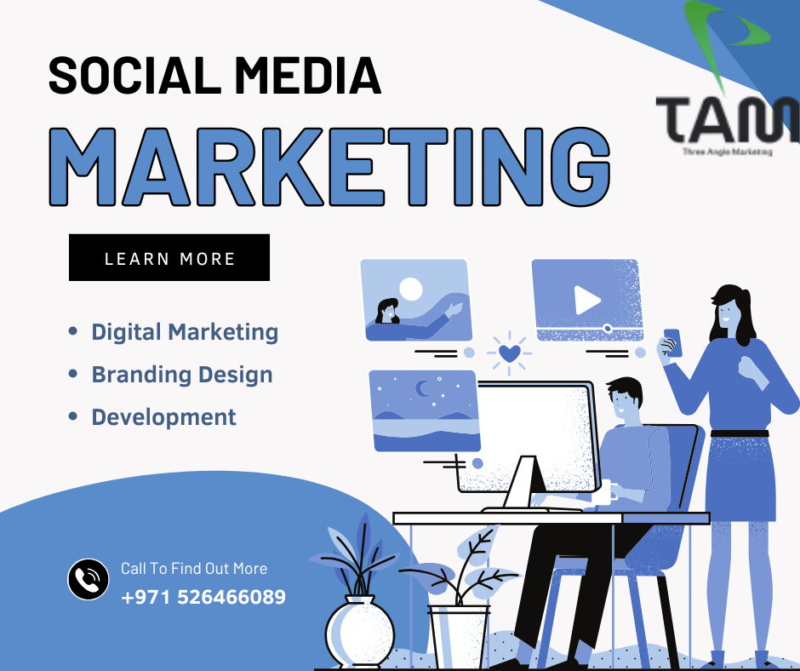
Gone are the days when brand growth depended entirely on market trends and competition levels.
Nowadays, brand growth depends on the social image of a brand in Dubai. Now consumers, while sitting on social media, decide the fate of a brand in the long run of the business.
As the list of social platforms and tools continues to grow, the task of coming to terms with this particular environment becomes rather challenging.
It proves beneficial to team up with a leading Social Media Marketing Agency in Dubai if the management of your social sites lacks sufficient knowledge and the formulation of efficient strategies.
Here, in this blog, we aim to provide insight into why any business in Dubai should opt for such partnerships and what to do while selecting the agency.

The Growing Landscape of Social Media Marketing in Dubai:
In order to understand the growing landscape of the social media market, you need to develop an understanding of social media use, trends, and necessity. For more clarity to achieve, have a look at each factor in more detail.

Statistics on Social Media Usage in Dubai:
There are no two opinions that Dubai is one of the most technologically advanced regions in the Middle East. According to recent research, almost every UAE citizen spends 2 hours and 58 minutes on social media at least once in a while.
Findings of some Surveys performed recently reveal that the UAE has an active social media penetration of more than 90%. The major social networks include Instagram, Facebook, and LinkedIn. This increasing usage shows the need for organizations to embrace social media to be part of the new economic era.

Emerging trends in Dubai Social Market:
Technology is rapidly advancing and so is the social media marketing communication in Dubai. In recent times, two trends that have become very popular are the use of videos and influencer marketing. These are trends that need to be adopted in the competitive environment of Dubai.
That’s why you have to act fast and smartly, and adopt such emerging trends to create a strong online appeal. If you need more help to deal with emerging trends issues, you can also contact a reliable social media marketing agency in Dubai to streamline your strategies.
Furthermore, you can also use analytics in organizations to understand customers’ behaviors better.

Why Adopt Effective Social Media Strategies?
For any business operating in the competitive market of Dubai, the proper use of social media is not a choice anymore. Businesses that are more active in the social media platform are likely to expand the coverage of their business, recognize their corporation, and ultimately lead to sales of their products.
On the contrary, the absence of a proper social media strategy could be at a disadvantage. Crafting compelling social media strategies is the strong suit of a social media agency in Dubai, so make sure you contact the right one.

Benefits of Partnering with a Top Social Media Marketing Agency:
Are you not sure whether you should partner with a social media marketing Dubai agency? The right agency can help your brand come to the top in the face of tough competition. Have a look at what you can expect by partnering with a top social media marketing agency.

Expertise and Experience:
Your selected social media marketing company Dubai must have expertise in the relevant field. These expertise are pertaining to the best practices and industry trends, but not limited to these factors only.

Knowledge of Best Practices:
A reputable agency always has a wealth of knowledge on the best practices that can be adopted with regard to specific business specialties. Their knowledge is up to date on the trends and any changes that may be taking place in a certain social media platform. This way, a social media marketing agency in Dubai can make sure your campaigns will be relevant and will not contravene any policies.

Industry Trends:
Most social media agencies tend to focus on a certain sector, bringing to the table unique trends that standard conventional marketing may not capture. Such knowledge can make all the difference in agenda optimization and increase the effectiveness of your social networks.

Access to Advanced Tools and Technologies:
Apart from expertise and experience, a social media marketing agency also has access to advanced tools to make any campaign successful. Here are some advanced tools and technologies that an agency has access to:

Analytics Tools:
Leading agencies employ analytic tools that help in the monitoring of the outcomes of the implemented campaigns. These tools are very useful as they generate information that can be used for planning future marketing ventures. Additionally, such tools are also useful in determining whether the objectives are being met or not.

Content Scheduling Platforms:
Prospective and successful management of social media involves the right tools in order. Some of the many perks that agencies leverage with the use of content scheduling platforms are related to optimization of campaigns.

Strategic Planning and Execution:
Another major benefit of hiring an SMM agency in Dubai is connected with the process of strategic planning and execution. Let’s check out how this planning and execution process helps you out in the long run of business.

Custom Management Approaches:
Every brand is unique in nature that’s why it requires different methods to raise awareness and growth. A good agency is one that creates a tailored plan of actions that is singularly suitable for your brand and fits your goals in your social media marketing business.

Modification of Campaigns:
Social media is the fastest-growing platform that’s why it is essential to continue modifying your campaigns according to your business requirements. You can also track and adjust your campaigns for the best results and KPIs.

Criteria for Choosing the Best Social Media Marketing Agency in Dubai:
Here are some factors you need to consider before you select a top social media marketing agency in Dubai:

Portfolio and Previous Work:
- Agency Samples: It can help to provide a case study of past and on-going campaigns to allow the evaluation of agency’s performance when handling similar projects. All you need is to search for case studies which have been successful in areas that are related to your line of business.
- Client Testimonials and Reviews: This is an endorsement by previous clients about the performance of an agency. Recommendations from previous clients are a good testimony to the kind of services an agency offers to its clients.

Understanding of Local Market Dynamics:

- Specific Cultural Considerations: Due to the cultural differences that exist in Dubai, it is best to be considerate in the choice of topics for discussion. This is because an effective agency will develop relevant content according to to the specific dynamics of the market.
- Market Taste and Popularity: It is worth learning what type of products or services the local population favors. Agencies that have insights into these preferences will be in a position to apply them to your desired target group.

Range of Services Offered:

- Creation of content: Contrary to its meaning, content is still the king when it comes to interacting with your audience. A social media agency will provide you all-encompassing content creation that will ensure the posts generated are attractive.
- Community Management: As mentioned earlier, it is important to have a strong and active community involvement for the brands. When your agency has a strong community management, it will be easy for the organization to engage with this kind of audience.
- Based on such reasoning, agencies should offer services in both paid advertising and SEO to improve the reach of the targeted audience. These services make a point of making your brand visible to the target market at the times when it matters most.

Spotlight on Top Social Media Marketing Agencies in Dubai:
If you are looking for some recommendations to select the top SMM agencies in Dubai, here are some honorable mentions you can consider.
- Three Angle Marketing
- Digital Dot
- Digital Gravity
- Prism
- Legend1st
- Ignite Visibility

Final Thoughts:
It is crucial to cooperate with a social media marketing agency in Dubai to gain the necessary knowledge, instruments, and experience. Your choice of the agency should be based on the proper criteria to work with a company that matches your goals and objectives. Regardless of whether you work with Three Angle Marketing agency or any other, the proper choice can always change the situation and help your brand stand tall.
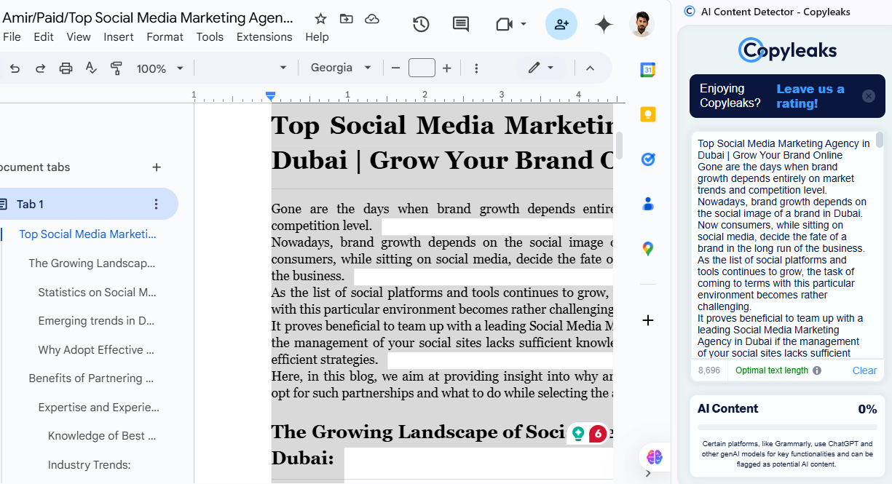

Brand Strategy Services Dubai

